|  |  |
| --- | --- |
| To: | City Executive Board |
| Date: | 20th March 2018 |
| Report of: | Head of Financial Services  Head of Business Improvement |
| Title of Report: | Integrated Performance Report for Quarter 3 2017/18 |

|  |  |  |
| --- | --- | --- |
| Summary and recommendations | | |
| Purpose of report: | | To update Members on Finance, Risk and Performance as at 31st December 2017. |
| Key decision: | | No |
| Executive Board Member: | | Councillor Ed Turner |
| Corporate Priority: | | Efficient and Effective Council. |
| Policy Framework: | | Corporate Plan |
| Recommendation: That the City Executive Board resolves to: | | |
|  | Note the projected financial outturn and current position on risk and performance as at the 31st December 2017. | |

|  |  |
| --- | --- |
| Appendices | |
|  |  |
| Appendix A  Appendix B  Appendix C  Appendix D | Corporate Integrated Dials  General Fund - Dec 2017 Forecast Outturn  Capital Programme - Dec 2017 Forecast Outturn  HRA - Dec 2017 Forecast Outturn |

# Introduction and background

1. This report updates the Board on the financial, corporate performance and corporate risk positions of the Council as at 31st December 2017. A brief summary is as follows:
2. **Financial** **Position**
   1. **General Fund** – the outturn forecast is projected to be a favourable variance of (£0.516) million against the net budget requirement of £21.056 million;
   2. **Housing Revenue Account** – the outturn forecast is projected to be in line with the Budgeted Surplus of (£5.619) million;
   3. **Capital Programme** – the outturn position is forecast to be a favourable variance of (£8.692) million against the latest budget of £61.039 million due to slippage into future financial years;
3. **Performance** – 75% (12) of the Council’s corporate performance targets are being delivered as planned, 13% (2) are below target but within acceptable tolerance limits and 13% (2) are currently at risk, as described in paragraphs 16 - 18 below.

**Corporate Risk Management** – There are no red corporate risks at the end of quarter two.

**Financial Position**

**General Fund Revenue**

1. The overall Net Budget Requirement agreed at Council in February 2017 was £21.056 million. Since setting the budget there have been transfers from reserves into the budget, these transfers represent unspent budgets from 2016/17 agreed to be carried forward into 2017/18 and have the effect of increasing the Net Budget Requirement. Conversely during the year grant income has been transferred into Earmarked Reserves as the expenditure relating to this funding will not take place until future years. As a result General Fund net budget has increased to £21.784 million.
2. During December there were a number of virements, authorised under delegated powers by the Council’s Head of Financial Services the most notable were the movement of the flexible homelessness grant into earmarked reserves, and the allocated funding for the Local Authority Trading Company (LATCo) setup being released from earmarked reserves.
3. The General Fund is forecasting a favourable variance of (£0.516), this is a net position and reflect the following key variances:

**Direct Services** - forecasting a favourable variance of (£0.600) million at year end. This reflects an overachievement of income in the following areas: Car Parks (£0.130) million; Motor Transport (£0.100) million; Engineering (£0.220) million and Commercial Waste (£0.150)

At the end of December the level of debt over 90 days stood at £0.342 million, a small reduction on the previous month. Positive work is being carried out by Direct Services and Finance to reduce this level of debt. Although the provision is adjusted at year end some of the overachieved income may subsequently need to be utilised to increase the bad debt provision.

**Community Services** are forecasting an adverse variance of £0.048 million at year end due to Rosehill Community Centre Health Hub income which will not be received as the lease will not come into effect until after 2018/19 due to delays in specification and agreement with the Hospitals trust on lease terms. This pressure has been included in the 2018/19 MTFP budget process.

**Planning, Sustainable Development and Regulatory** are forecasting an adverse variance of £0.036 million at year end due to the regrading of a post in Environmental Sustainability and reduced income on search fees.

1. Housing Benefit expenditure in relation to local authority error is forecast to be £156k above the upper threshold at which subsidy is lost.  Whilst undesirable; it should be noted that the service has implemented a significant improvement programme including providing targeted training for staff and system improvements which are ongoing.  This has resulted in improvements in accuracy rates in the processing of Housing Benefit claims (70% to 85% pre and post training) and a reduction in the forecast loss from such errors (£150k compared to £253K in 2016/17). The percentage of incorrectly paid benefit compared to total Housing Benefit expenditure is 0.27%.
2. Administrative delay arising from late processing of changes to claims has improved due from the 12 week backlog of correspondence at the start of the year reducing to 7 weeks currently.  The backlog includes all year end processing work affecting next years’ entitlement and an additional 2,500 more changes than received last year.
3. The largest increase in demand compared to last year has been due to Universal Credit (UC). Each UC data share record is captured and indexed as a BEOB (evidence of Benefits). This year so far we have indexed 3,668 BEOBs compared to 1,123 at the same time last year. These changes inform entitlement to other benefits such as Housing Benefit, Council Tax Reduction and Discretionary Housing Payments. Quite often these are required, and at other times the information provided is unnecessary or even blank. As an example, since December an account has received 13 different notifications linked to the circumstances of the household, and it may now be that more changes are being notified by claimants as part of the requirement to maintain their journal.

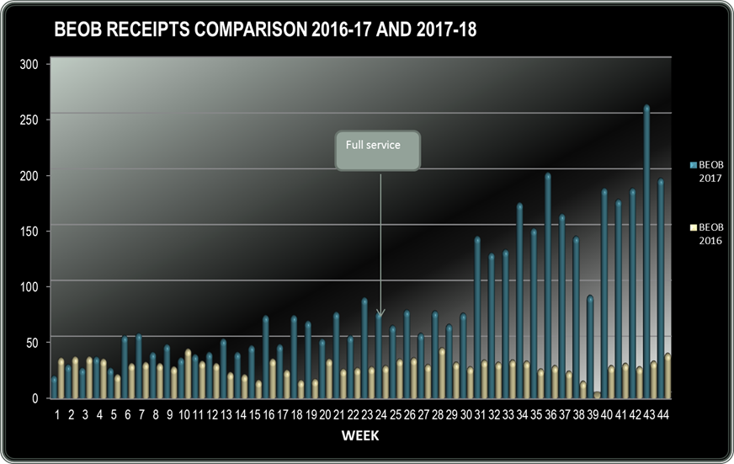

Whilst the correspondence does not directly affect the Councils benefit subsidy, the processing of such information is a significant drain on the Council limited resource, diverting them from dealing with Council benefit claim and inevitably leading to admin delay and loss of subsidy. The Government do not seem to recognise the impact of these unintended consequences on the authority and representations are being made via the Leader of the Council and the local MP. Administrative delay for last year was £235k and so far the level is £226k  for this  year. Year-end forecast is £255k at the end of March.

1. Losses of subsidy are offset against income received from overpaid Housing Benefit. In addition the Council has an earmarked reserve of around £500k which it will use to cushion the impact on the Revenue account of Housing Subsidy losses at year end.

**Housing Revenue Account**

1. The budgeted surplus agreed at Council in February 2017 was £5.619 million. Since setting the budget, the net budget has increased by £0.670 million which represents budgets being carried forward from 2016/17 into 2017/18. This has been funded by a corresponding release from Earmarked Reserves to ensure that the budgeted surplus remains unchanged.
2. The £0.670 million relates to regeneration schemes at Blackbird Leys and Barton (£0.234 million); staffing cost in the incomes team (£0.050 million); procurement of furniture for sheltered accommodation (£0.086 million); additional funding for the new housing and management system (£0.200 million) and legal fees associated with the Tower Block Refurbishment (£0.100 million).
3. A total of £1.0 million has been transferred from the Major repairs Reserve into capital to fund the recladding of Windrush and Evenlode Towers following approval of this expenditure by CEB and Council in August 2017.
4. The Housing Revenue Account is currently forecast to be in line with the approved budgeted surplus of £5.619 million. The £0.292 pressure which was highlighted in Quarter 2 budget monitoring has now been mitigated with additional income primarily arising from Housing rents; details of which are given below:

* Dwelling Rent – favourable variance of (£0.080) million due to slow down in RTB disposals, temporary accommodation income higher than expected and a move of 142 properties to formulae rent.
* Service Charges – favourable variance of (£0.160) million due to additional service charge income being received following an increase in number of leaseholders; inflationary increases and removal of the service charge discount.
* Miscellaneous Income – favourable variance of (£0.115) million due to a review of the budgets relating to wayleaves; ad-hoc pieces of land and court costs has resulted in increased income. There has also been a favourable review of the telecommunications licences budget for the Tower Block leading to a further saving.
* Management and Services (Stock Related) – adverse variance of £0.128 million due to additional legal costs associated with the Leaseholders Tribunal case on the Tower Block refurbishment programme
* Miscellaneous Expenditure (Non-stock related) – favourable variance of (£0.100) million due to the budget for the demolition of a sheltered schemes which was originally planned to be carried out in 2017/18 being deferred until 2018/19 and originally funded from ‘Other reserves’ which have now been put back. There is nil effect on the revenue account

Responsive & Cyclical Repairs – favourable variance of (£0.065) million due to underspends on night-time call outs and gas responsive repairs and the activity associated with voids is less than expected.

**Capital**

1. A robust review of the Capital Programme has been carried out as at the end of Quarter 3, which has resulted in some considerable slippage. The projected outturn on the Capital Programme is currently a total of £52.348 million, a variance of (£8.692) million against the latest budget. The main variances are:

General Fund

* Slippage of (£0.255) million on the Housing System Replacement into 2018/19. The successful bidder has been identified, and the slippage is due to the initial payment to the supplier not being required until May 2018.Slippage of (£0.150) million on the End-point devices project, the procurement process is underway and roll out of the new devices is due to start in early summer 2018.
* Slippage of (£0.025) million on the East Oxford Community Centre project whilst the project is re-evaluated and a further report submitted to CEB;
* Re-profiling (£3.886) million on the Purchase of Homeless Properties scheme. The original £10m programme was to fund acquisitions over an 18 month period, not 12. So an expectation that some of this spend would occur in 2018/19 was anticipated and this is now reflected in the revised profile for December. £10m will eventually be spent on properties for the homeless
* Slippage of (£0.060) million on the Marsh Road Recreation Ground Car Park extension . Planning was approved on 02.08.17 with conditions. Information has been submitted to discharge these conditions, subject to approval by the Chair of the Planning Committee. The project is likely to start shortly with one planning condition yet to be discharged.
* Slippage of (£0.300) million on the Feasibility Fund due to no new schemes being identified that will require feasibility funding;
* Slippage of (£0.150) million on the Cave Street project due to delays in working up of the project,
* Slippage of (£0.225) million on the Ship Street and New Road project, New Road redevelopment is on site but Ship Street is continuing to cause challenges in the redevelopment.;
* Slippage of (£1.134) million on the Westgate area public realm improvements into 2018/19 awaiting the legal documentation to be signed to allow the payment to be made;
* Slippage of (£0.750) million on the Barton Community Centre project. The order is due to be placed imminently, but the majority of spend will be in 2018/19 ;

Slippage of (£0.150) million on the Marsh Road Depot Extension -Planning approved on 02.08.17 with conditions. Site preparation has recently commenced.

HRA

* Slippage of (£0.828) million on Tower Blocks refurbishment programme in 2018/19, this is due to the agreement of the replacement cladding and that this will mean the project will run through into July 2018;
* Slippage of (£0.100) million on Great Estates Programme into 2018/19 due to a the project running behind schedule
* Slippage of (£0.350) million on the Barton Regeneration Scheme into 2018/19, due to the project not expecting to start until February 2018;
* Slippage of (£0.150) million on the Lift Replacement Programme into 2018/19, the consultants have been appointed and are currently working on the specifications with a view to tender in November 2018.

.

**Performance Management**

1. There are sixteen corporate performance measures that are monitored during the year. Twelve (75%) are being delivered as planned, two (13%) are below target but within acceptable tolerance limits, and two (13%) are at risk of not meeting their target.
2. Of the ten that are being delivered as planned, two relate to Vibrant and Sustainable Economy, three relate to Meeting Housing Need, three to Cleaner Greener Oxford, two to Strong and Active Communities and two to An Efficient and Effective Council.
3. The two measures that are not meeting their targets are as follows:

* **Number of people using leisure centres** – the target is 1,000,000 and an actual of 867,021 at the end of the third quarter has been achieved. Whilst still under target at YTD the wider activity offer and number of affordable and accessible leisure facilities in the city has increased. Officers are working with Fusion to better promote their services and to continue to focus on attracting more participation from target groups.
* **Amount of employment floor space for development (m2)** – Target of 11,250 m2 and an actual of 173 m2. There has been an increase of 1921 m2 and a loss of 2012 m2 this month. We continue to work with the developers operating in the local market to bring forward the key sites to meet this target. Employment space has is being eroded due to permitted development rights being realised; also we have new support to enable the realisation of Osney Mead and Northern Gateway.

**Corporate Risk**

1. There are no Red risks being reported in the third quarter of 2017/18 and there are nine amber and one green risk.

# Financial implications

1. All financial implications are covered in the body of this report and the Appendices.

# Legal issues

1. There are no legal implications directly relevant to this report.

# Level of risk

1. All risk implications are covered in the body of this report and the Appendices.

# Equalities impact

1. There are no equalities impacts arising directly from this report.

|  |  |
| --- | --- |
| **Report author** | Nigel Kennedy  Helen Bishop |
| Job title | Head of Financial Services  Head of Business Improvement |
| Service area or department | Financial Services/Business Improvement |
| Telephone | 01865 252708 |
| e-mail | nkennedy@oxford.gov.uk/hbishop@oxford.gov.uk |

|  |
| --- |
| Background Papers: None |